Ex.no: ONLINE COURSE RESERVATION SYSTEM
Date:

AIM:

To Design ,Implement and Test the online course reservation system described in the given problem statement .

PROBLEM STATEMENT

The aim is to design a course registration system for the admission of students in xyz college of technology for the academic year. All processes involved in the course registration system are computerized.

It must contain all the details about:
Student
Course offerings
Registering a course
Availability of courses
Eligibility for admission

This registration system enables the admission of candidates into the institution on the basis of their educational and social background. This software will be accessible to candidates who are short listed by the institution with their respective application numbers. The candidate has to register their desired branch from the available courses.

The registration must include the following details:
Application no
Student information
Course selected
Course availability
Eligibility
If a student wishes to change his/her course, then the schedule is updated. To update a schedule, the student needs to be logged in. then student can select any other course from the available list of courses. And the schedule is updated.

If a student wishes to cancel his/her course, the students current schedule is retrieved and displayed first. Then the system prompts the user to confirm the deletion of schedule. If confirmed ,the student is removed from the course offerings.

USECASE DIAGRAM:

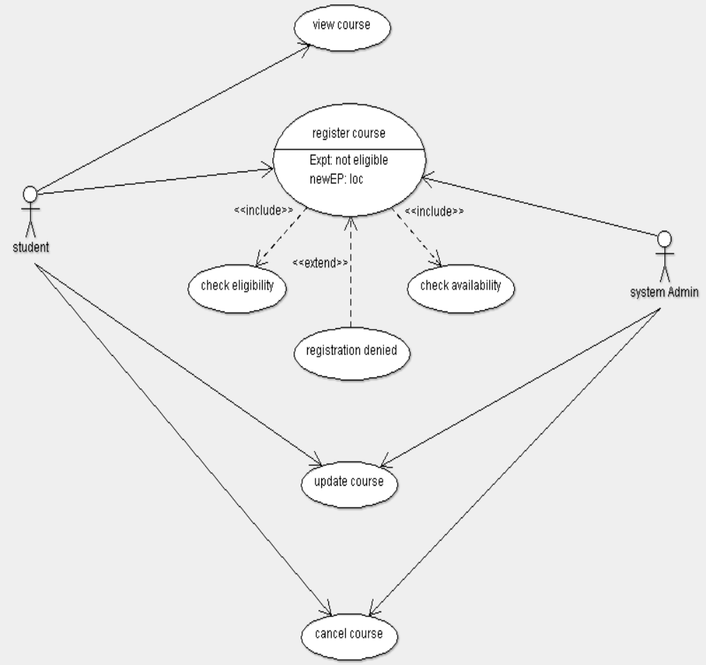

CLASS DIAGRAM:

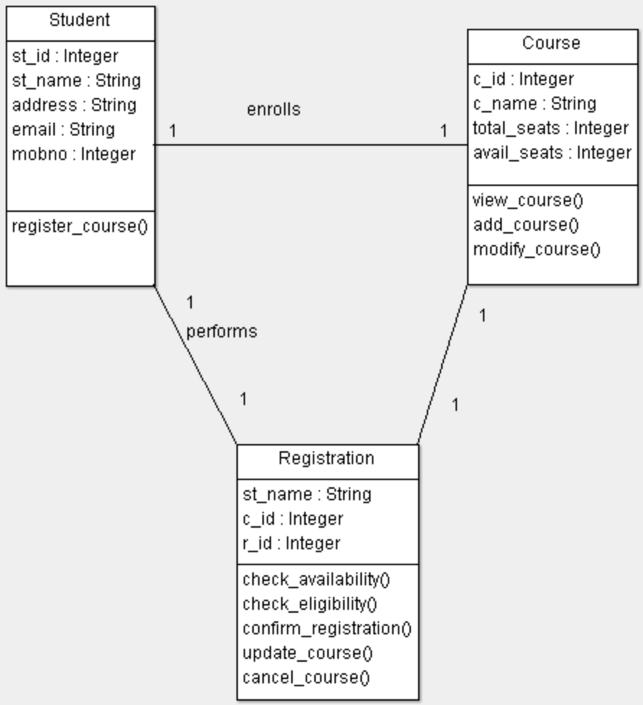

SEQUENCE DIAGRAM:

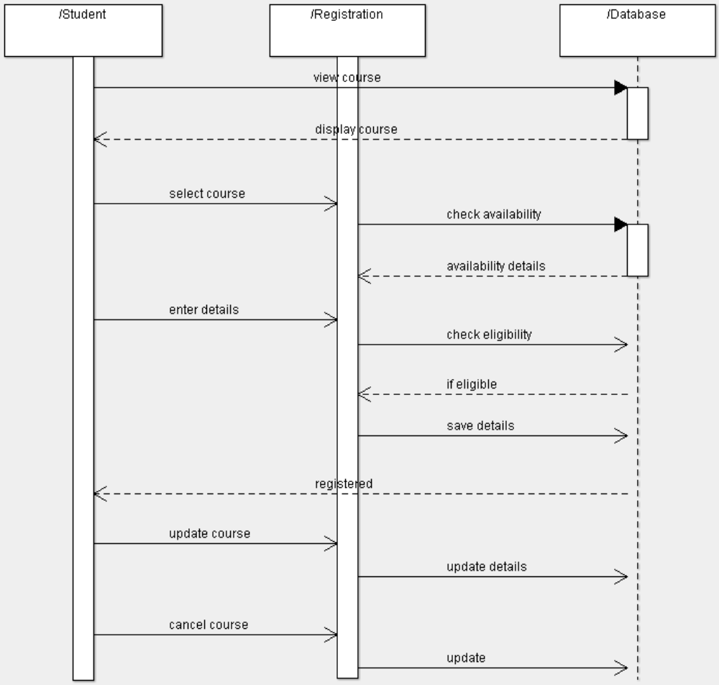

ACTIVITY DIAGRAM:

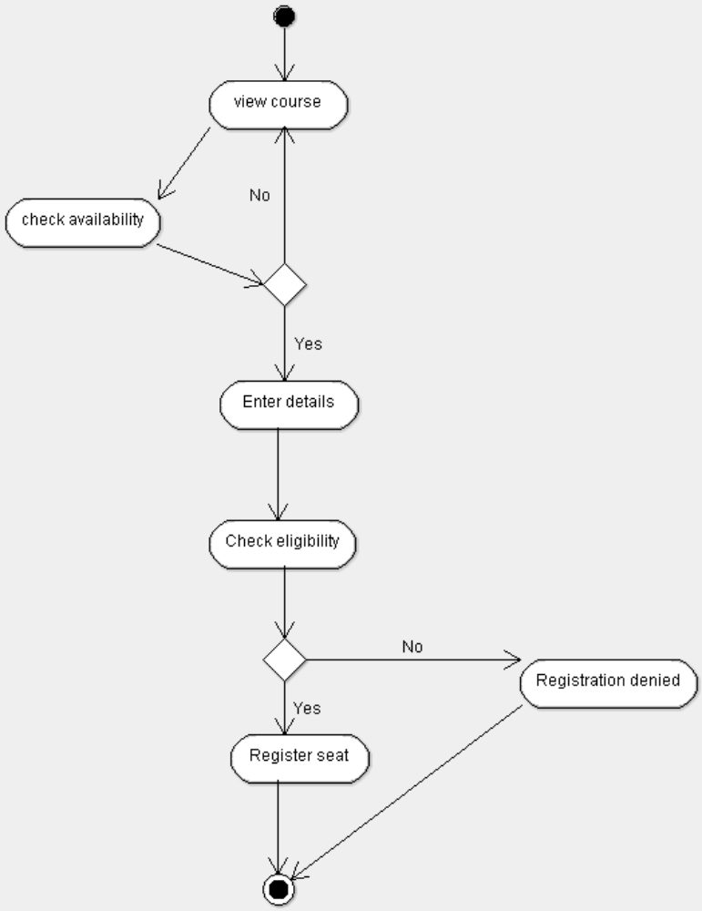

STATE CHART DIAGRAM:

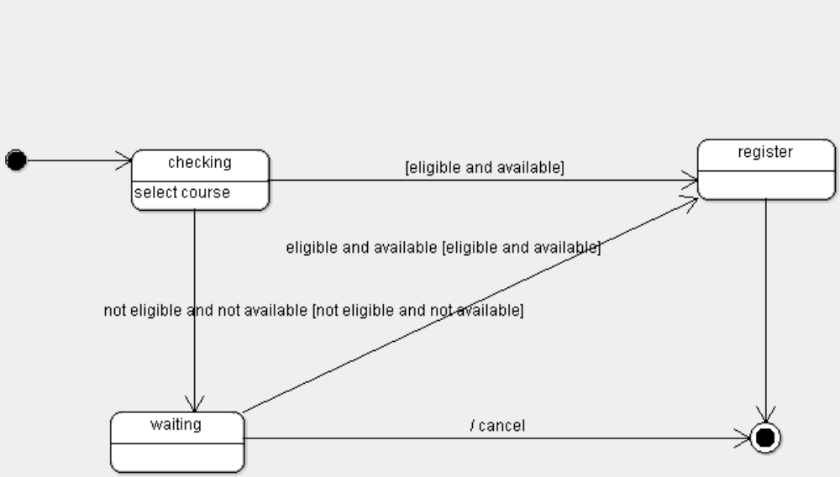

COMPONENT DIAGRAM:

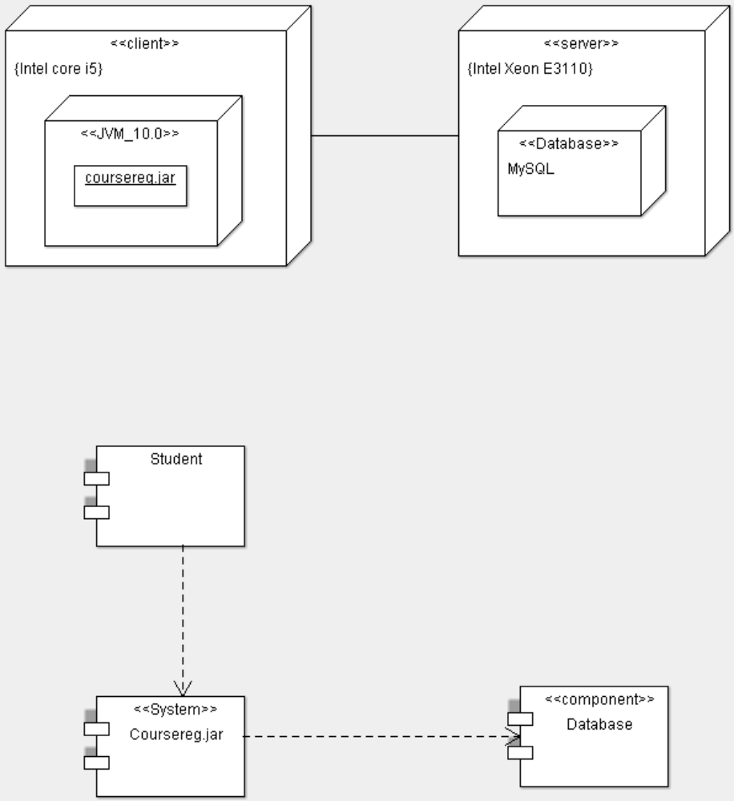

DEPLOYMENT DIAGRAM :

IMPLEMENTATION & TESTING :
//Course.java
class Course
{
public static int[] c_id = new int[]{1,2,3} ;
public static String[] c_name = new String[]{"CSE","IT","EIE"};
public static int tot_seats = 20;
public static int[] avail_seats=new int[]{20,20,20};

public void view_cour()
{

System.out.println("Course Name\t Course ID\t Total Seats\t Available Seats \n");
for(int i =0;i<3;i++)
{

System.out.println(c_name[i]+"\t\t "+c_id[i]+"\t\t "+tot_seats+"\t\t "+avail_seats[i]+"\n");
}
}

}

//Reservation.java
import java.util.Random;

class Reservation extends Student
{
public int i;

public int check_avail(int ci)
{
for(i = 0;i<3;i++)
{
if(ci==c_id[i])
{
if(avail_seats[i] >0)
{
return i ;
}
else
{
return -1;
}
}
}
return -1;
}

public void reg_confirm()
{
System.out.println("Enter the course id to register : ");
int ci = s.nextInt();
int b=check_avail(ci);
if(b!=-1)
{
Random ran= new Random();
avail_seats[b]--;

System.out.println("Your Registration id : "+ran.nextInt(100));
System.out.println("Registration successfull");
}
}

public void cancel()
{
System.out.println("Enter course id : ");
int cc = s.nextInt();
System.out.println(“Enter your registration id : ”);
int rid=s.nextInt();
for(int j=0;j<3;j++)
{
if(cc == c_id[j])
{
avail_seats[j]++;
System.out.println("Cancellation successfull");
}
}
}
}

//Student.java
import java.util.Scanner;

class Student extends Course
{
public String st_name;
public String addr,email;
public long mob;

Scanner s = new Scanner(System.in);

public void reg_course()
{
System.out.println("Enter Name : ");
st_name = s.nextLine();
System.out.println("Enter Address : ");
addr=s.next();
System.out.println("Enter Email : ");
email=s.next();
System.out.println("Enter Mobile number : ");
mob=s.nextLong();

Reservation r = new Reservation();
r.reg_confirm();

}
}

//OCR_System.java
import java.util.Scanner;

public class OCR_System extends Reservation
{
public static void main(String args[])
{

Scanner sc= new Scanner(System.in);
Student st = new Student();

int a;
do
{ st.view_cour();
System.out.println("1.Register\n2.Cancel\n3.Exit\n");
System.out.println("Enter your choice : ");
a=sc.nextInt();

switch(a)
{
case 1:
st.reg_course();
break;

case 2:
Reservation res=new Reservation();
res.cancel();
break;
}

}while(a!=3);
}
}

OUTPUT:

Course Name Course ID Total Seats Available Seats
CSE 1 20 20
IT 2 20 20
EIE 3 20 20

1.Register
2.Cancel
3.Exit

Enter your choice :
1
Enter Name :
Nafeezabbas
Enter Address :
nemli,arrakonam.
Enter Email :
nafeezabbas@gmail.com
Enter Mobile number :
8767546738
Enter the course id to register :
1
Your Registration id : 87
Registration successfull

Course Name Course ID Total Seats Available Seats
CSE 1 20 19
IT 2 20 20
EIE 3 20 20

1.Register
2.Cancel
3.Exit

Enter your choice :
1
Enter Name :
Nishantbhushan
Enter Address :
thiruvottiyur,chennai.
Enter Email :
nishantbhushan05@gmail.com
Enter Mobile number :
9600278246
Enter the course id to register :
1
Your Registration id : 54

Registration successfull

Course Name Course ID Total Seats Available Seats
CSE 1 20 18
IT 2 20 20
EIE 3 20 20

1.Register
2.Cancel
3.Exit
Enter your choice :
2

Enter course id :
1
Enter your registration id : 54
Cancellation successful

Course Name Course ID Total Seats Available Seats
CSE 1 20 19
IT 2 20 20
EIE 3 20 20

1.Register
2.Cancel
3.Exit

Enter your choice :
3
BUILD SUCCESSFUL (total time: 2 minutes 36 seconds)

TEST REPORT 1

Product : Online Course Reservation
Use case : Register course

Test Case ID | Test Case / Action To Perform | Expected Result | Actual Result | Pass/Fail
- 1 | Register course | Gets student details as input | Enter Name :  Nishantbhushan  Enter Address :  thiruvottiyur,chennai.  Enter Email :  nishantbhushan05@gmail.com  Enter Mobile number :  9600278246 | Pass
 | After getting student details | Generates and displays Registration id | Your Registration id : 54 | Pass

TEST REPORT 2

Product : Online Course Reservation System
Use Case : Cancel course

Test Case ID | Test Case / Action To Perform | Expected Result | Actual Result | Pass/Fail
- 1 | Cancel course | Displays “Cancellation successfull” and increments available seats. | Cancellation successfull  Available seats : 19 | Pass

